TNE20003 – Internet and Cybersecurity for Engineering Applications

**Portfolio Task – Lab 4 Pass Task**

Aims:

* To investigate how routing works and what routers do with broadcast packets.

Preparation:

* View “[Network Devices - Routers and Switches”](https://swinburne.instructure.com/courses/54168/pages/topic-3-network-devices-routers-and-switches-2?module_item_id=3692546)

Due Date:

* All tasks in this lab are to be completed and demonstrated to your Lab instructor preferably during or at the end of the current lab, but if you do not complete the tasks you may demonstrate it at the beginning of your next lab class.

Task 1.

**Build the network provided in figure 1 with Cisco Packet Tracer and observe the routing tables in each of the routers**

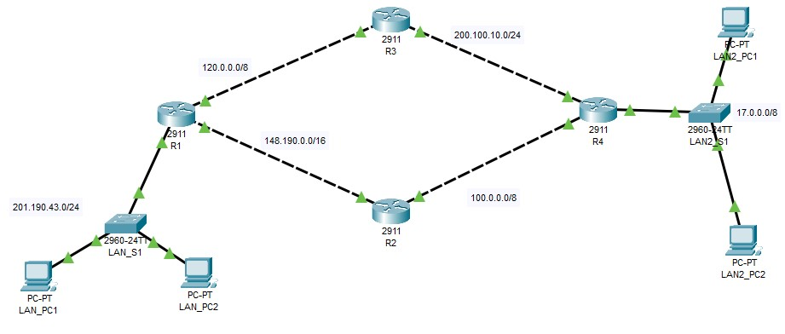

Figure 1

Task 2.

1. Implement the network shown in figure 1 above.

If you need help creating the diagram refer to the instructions in labs 1 & 2.

1. Investigate the initial routing table entries in each of the routers
   1. On **R1** go to the CLI mode and press enter until you see **R1>**
   2. At the **R1>** prompt type **“enable”** This will take you to the privileged mode where you can see the status of the router.
   3. At the **R1#** prompt type **“sh ip ro”**  this is short for show ip route.
   4. Note what is displayed. You should see 3 C’s along with some network addresses. If you do not, seek help.
   5. Repeat steps (a)-(d) above on the other 3 routers and note what you see.

R1 has 3 c and l

R2 has 2 c and l

R3 has 2 c and l

R4 has 3 c and l

1. Configure routing paths for complete end-to-end connectivity.
   1. Next, we will configure a dynamic routing protocol (find out the purpose of a dynamic routing protocol if you are interested). Go back to **R1** and at the **R1#** prompt type **“conf t”**, which is short for configure terminal.
   2. Your prompt should now be **R1#(config)**. To enter the mode where we configure the routing protocol type the command **“router rip”.**
   3. Your prompt should now be **R1#(config-router)**. Now we must advertise all networks that we want other routers to know about. Usually this is all connected networks. At the current prompt type the following commands; **“network 201.190.143.0”, “network 120.0.0.0” &**

# “network 148.190.0.0”

1. At the **R1#(config-router)** prompt type **“do sh ip ro”.** Note that when you are in a sub-config mode, ie any config mode other than **R1#(config)** you will need to use the “do” before entering the command you want to use.
2. Now go to the other 3 routers and type the **“sh ip ro”** commandat the **R?# prompt**. What do you see?
3. Why has the output not changed?

The output didn’t change because dynamic routing has not yet been configured on the other routers

1. Now configure routing on all routers.
   1. Next we will configure a dynamic routing on **R2** and at the **R2#** prompt type **“conf t.**
   2. Your prompt should now be **R2#(config)**. To enter the mode where we configure the routing protocol type the command **“router rip”.**
   3. Your prompt should now be **R2#(config-router)**. Now we must advertise all networks that we want other routers to know about. Usually this is all connected networks. At the current prompt type the following commands; **“network 100.0.0.0” & “network 148.190.0.0”**
   4. At the **R2#(config-router)** prompt, type **“do sh ip ro”.** Explain what do you see?
   5. Go back to **R1#** and type **“sh ip ro”.** Explain what you see?
   6. Go back to **R3#** and type **“sh ip ro”.** What do you see? Why don’t you see the new networks you saw in **R1 & R2**?

Because I haven’t configured router rip on R3

* 1. Repeat (a)-(f) and make sure that all routers are running RIP and advertising all of their connected networks like you did for **R1 & R2.**

1. Trace the data path from a PC.
   1. Click on the LAN_PC1 and choose “**desktop”** and then click on the **“command prompt”**

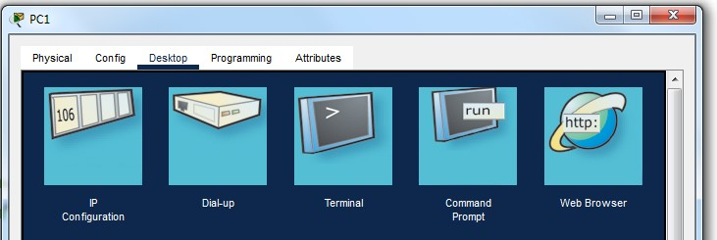

* 1. In the **“command prompt”** window type **“tracert (ip address of LAN2_PC1)”**. Conversely you may use the simulator and the envelopes like you did in lab 1. Do this 3 times. The outputs should vary.
  2. Note what is displayed. Which way did the traffic go? Can you explain why?

The traffic dynamically transmits throughout the interconnected networks depending on the administrative distance and the metric. It can change case-by-case depending on these factors.

1. Investigate path choice in routers.
   1. Add another router **R5** between **R3** and **R4**. Keep the network address of 200.100.10.0/24 between **R3** and **R5** and then use the network of 200.50.50.0/24 between **R5** and **R4**. Remember to change the **R4** interface address that belonged to the 200.100.10.0/24 network from before.
   2. Now repeat step 5 above and click on the LAN_PC1 and choose “**desktop”** and then click on the **“command prompt”**

* 1. In the **“command prompt”** window type **“tracert (ip address of LAN2_PC1)”**. Conversely you may use the simulator and the envelopes like you did in lab 1. Do this 3 times.
  2. Note what is displayed. Which way did the traffic go? Can you explain why?
  3. On **R1** find which of your GigabitEthernet interfaces connects **R1** to **R2**. Then check the “ON” box so that it is not selected or is off. This action turns the interface off, meaning that it will stop forwarding traffic out of this interface. See the pic below:

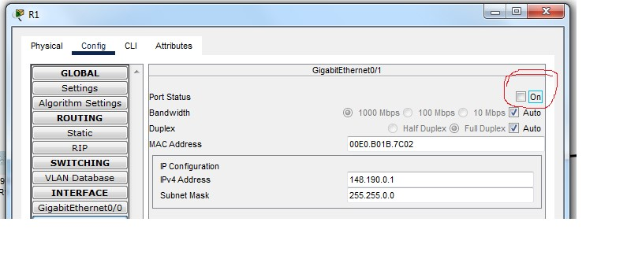

1. Verify that routers block broadcasts.
   1. As in lab 1, click simulation and then under edit filters only enable/tick IPv4 and under that tab the ARP and ICMP protocols as in the pic below

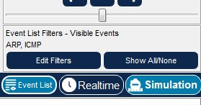

* 1. Add another 5 PCs to your design space and connect them to LS1. Label them as you want. You do not need to give them IP addresses as LS1 will work only at L2.
  2. Verify that both LAN_PC1 & LAN_PC2 have empty ARP tables. If they don’t enter the command **arp –d** in the command prompt for either or both PCs. Also verify that LS1 has an empty CAM table, if not enter the command “**clear MAC address-table”.** You know that ARP is a broadcast process, requesting to find the MAC address that matches the user-entered IP address.
  3. Click on the envelope and then click on LAN_PC1 as the source and the LAN2_PC2 as the destination.
  4. Run the simulation. What do you observe? Comment on what happens to the first packet/envelope and then the second packet/envelope.

This simulation shows an Arp request from the switch to fill the MAC address table. A broadcast is sent to ALL surrounding PC’s but the only successful transmissions is with the routers port as that is the intended destination of the packets.

* 1. Did the router pass on the first packet/envelope? Explain why or why not.

*~~~~~ End of Lab ~~~~~*